Gesture Based UI Project

Myo Controlled Arduino remote control car
By Abigail Culkin and Sarah Carroll

Purpose of the application
The purpose of this application is to further educate ourselves on the gestures involved in controlled a car with a myo armband.
Objectives
- Create a remote-control car with an Arduino controlling the wheel turning and a motor controlling the wheel spin.
- Connect the Arduino and Myo to enable the myo control the car.
- Come up with user friendly gestures to use for the use of the car.
- Program the myo to perform the actions by the gestures and send the information to the Arduino.
Gestures Identified as appropriate for this application
In order to understand the ideal gestures to use for this application we carried out research both online and asking friends and family who have never used the myo to attempt to control the car with it.This gave a good idea of peoples natural movement.

Moving forward:
In order for the vehicle to move forward the user must perform the finger spread action with the myo armband on the top of their forearm.

Move right:
For the vehicle to move right the use must do the wave out gesture while wearing the myo armband.

Move Left:
When the user wishes the vehicle to move left they must do the wave in gesture with the myo armband.

Stop:
In order for the vehicle to stop the user should rest their hand and the vehicle will come to a stop.

Hardware used in creating the application

During the development process of the application we started by testing the movement of the Arduino with a joystick. This helped with the understanding of the motors and movement of the car prior to adding the myo.

Myo Armband:
The Myo armband lets you use the electrical activity in your muscles to wirelessly control your computer, phone, and other favourite digital technologies. With the wave of your hand, it will transform how you interact with your digital world. The myo armband is wireless and connects by Bluetooth.

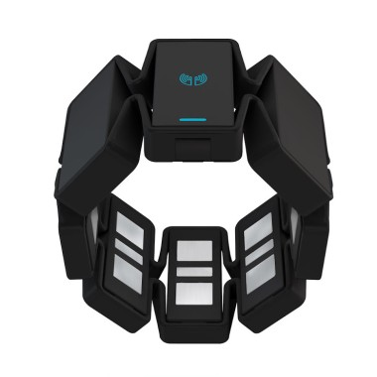
Setup MYO:
- Open the Armband Manager from the MyoConnect menu.
- Click the + button in the bottom left corner of the window.
- Tap the Thalmic Labs logo on your Myo armband to the USB Bluetooth adapter.
- Your Myo is now connected!

Arduino:
The Arduino UNO is an open-source microcontroller board based on the Microchip ATmega328P microcontroller and developed by Arduino.cc. Arduino is an open-source hardware and software company. We have used the Arduino to connect to the motor of the car in order to direction and move the car.
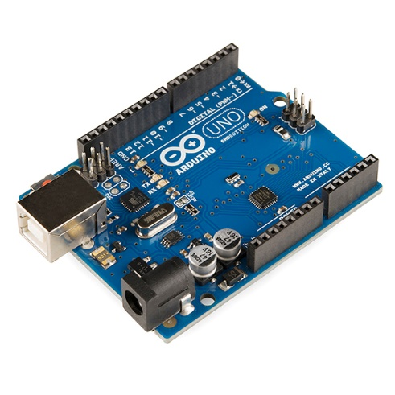
Arduino setup:
- The setup of the Arduino is done in the code.
- The setup() function is called when a sketch starts. Use it to initialize variables, pin modes, start using libraries, etc. The setup function will only run once, after each powerup or reset of the Arduino board.

